# **OVERVIEW**

The sales table is a critical part of any business, as it records all of the transactions that have taken place within a given period of time. This table is usually used to track the revenue generated by the business, as well as to identify any trends or patterns that may be emerging in the market.

In addition to the sales table, there are several other tables that are commonly used in businesses to track various types of data. For example, the returns list table is used to track all of the products that have been returned by customers. Similarly, the product reviews table is used to track customer feedback and ratings on various products.

Another table used by the companies is the ‘campaigns table’, which is used to track the effectiveness of marketing campaigns. Finally, the other promotions table is used to track any other promotional activities that the business may be engaged in, such as discounts or special offers.

The methodology we followed during this period examining the datas row by row and at the end get an insight or pre-look about our feature analysis. At this point we marked the features from which we have taken the following actions on the table. If you do not see any table below the explanation, that means we left the table with its main existing columns.

In this report, the following tables received from The Mynes Company will be used in our analyses.

* Sales
* Amazon Campaigns
* Meta Campaigns
* Refunds
* Product Reviews

## **SALES TABLE**

When we analysed the sales table, the raw data we received contained 190,000 rows. Almost more than half of these rows consisted of empty rows. As a result of the analysis, all of these empty rows were removed from the data set. Then, data in the form of day, month and year were obtained from the date columns. And columns such as TotalWeight, DispatchUnitCost were removed because they contained many empty or zero values.

After these operations, new features such as TP_per_Quantity,ST_per_Quantity,UK_CPI,Turkey_CPI,Net_Profit,Day_Time were added according to the need. 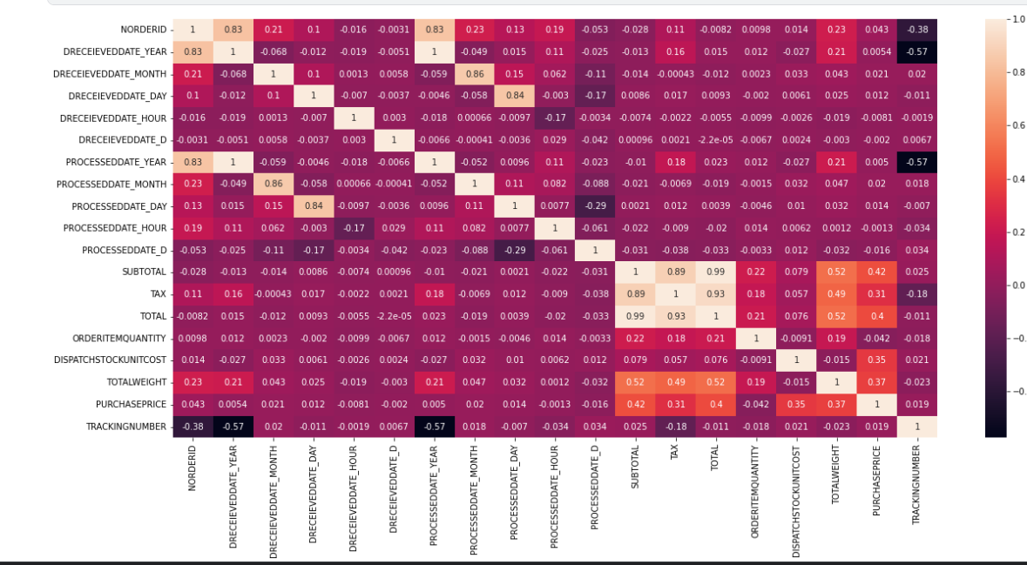

**Table 1: Correlation Map of Sales Table**

|  |  |
| --- | --- |
| **FEATURE (COLUMN)** | **THE FUNCTION OF COLUMN** |
| nOrderId | * The uniqiue ID of each order taken by the company. |
| Company | * The company which shops or buys items. |
| Customer ID | * The ID number of customer |
| dReceievedDate | * The Date on which orders taken |
| Country | * Country of the customer |
| status | * Status of Orders (paid or unpaid) |
| Processed | * processing of the order if it is true the order is delivered to customer. |
| ProcessedDate | * The date of the delivery process begins |
| Source | * The source of orders taken(Amazon,Ebay etc.) |
| Currency | * The currency on that an order transacted |
| Subtotal | * The Price without tax |
| Tax | * The amount of tax a customer paid on an order |
| Total | * The Total price a customer paid on an order |
| OrderItemSKU | * Unique item number which is on sale |
| OrderItemTitle | * The ItemTitle which a customer sees on sale platform |
| ItemCategory | * Brands which items on sale |
| DispatchStockUnitCost | * Delivery Cost of an item |
| OrderItemQuantity | * Quantity of items order per nOrderID |
| TotalWeight | * The weight of dipatched goods. |
| PurchasePrice | * Purchase price of items sold |
| TrackingNumber | * Delivery tracking number of items sold |
| PostalService | * The postal service over it delivery sent |

**Table 2 - Raw Features of Sales Table**

|  |  |
| --- | --- |
| **FEATURE (COLUMN)** | **ACTIONS TAKEN** |
| dReceievedDate | The column is splitted up in to the following columns.To get insight about sales date based on time. The main column also stays.  •DRECEIEVEDDATE_YEAR •DRECEIEVEDDATE_MONTH •DRECEIEVEDDATE_DAY •DRECEIEVEDDATE_HOUR •DRECEIEVEDDATE_WEEKDAY  Tıme serıes analizlerinde aylık, gunluk, haftalik tahminlerde kullanmak için yukarıdaki feature’lar eklendi. |
| ProcessedDate | It is also one splitted up following columns.The main ProcessedDateColumn also stays. •PROCESSEDDATE_MONTH •PROCESSEDDATE_YEAR •PROCESSEDDATE_DAY  •PROCESSEDDATE_HOUR  •PROCESSEDDATE_WEEKDAY  Tıme serıes analizlerinde aylık, gunluk, haftalik tahminlerde kullanmak için yukarıdaki feature’lar eklendi. |
| DispatchStockUnitCost | * There was lots of zero values so we decided to drop it. Also it didn’t give so much insight. |
| TotalWeight | * This column did not give us the expected research perspective. |
| TrackingNumber | * It was determined that there was a delivery tracking number, but the process of obtaining the desired information did not take place. |
| Processed | * After dropping false values then the column was dropped. |
| TP_Per_Quantity | * We would like to know the price that a customer paid per quantity with tax. * Birim fiyat analizlerinde bu feature’I kullanilacaktir. |
| ST_Per_Quantity | * We would like to know the price that a customer paid per quantity without tax. * Birim fiyat analizlerinde bu feature’I kullanilacaktir. |
| UK_CPI | * To use it on analysis as on the project instructions * Nedensellik (Enflasyonun ciro, satis ve kârlilik uzerindeki etkisi) analizlerinde bu feature olusturulmustur. |
| Turkey_CPI | * To use it on analysis as on the project instructions * Nedensellik (Enflasyonun ciro, satis ve kârlilik uzerindeki etkisi) analizlerinde bu feature olusturulmustur * Tedarik ulkesi Turkiye oldugu icin bu feature eklendi. |
| Net_Profit | * To know the net profit of the seller per sale (Subtotal-PurchasePrice) |
| Day_Time | * 24 hours of a day splitted up 4 parts like 'AfterNoon','Night','Early Morning' and 'Morning' |
| status | * There was no different values as 'PAID' because of that we have dropped this. |

**Table 3 - Actions Taken on Sales Table**

### **1.1.1 Recommendations for Sales Table**

When the analysis phase of the sales table was over, it was seen that most of the rows were filled with blank data. Although the exact reason for this is not known, it is thought that if it is a technical malfunction, the cause of the malfunction must be found. In addition, it has been determined that some zero values on data such as on columns DispatchUnitCost, TotalWeight recommended to be recorded completely. In addition, it is recommended to the company that the process date data with the missing date is required to be filled in correctly.

Finally, unidentified characters were seen in a few product titles in the table, and it was determined that these characters belonged to the Swedish language. In this regard, it can be eliminated with this character with a renewal to be made within the system.

We also found 101 duplicate rows in this table, which we think is a system error.

## **RETURNS TABLE**

The raw form of the data in the returns table contained approximately 15 thousand rows of data, and it was seen that more than half of this data was filled with null raws, as in the Sales table, in this context, these rows were removed from the data set.

The remaining columns in this table were found to contain important data and we did not need to add any new columns.

|  |  |
| --- | --- |
| **FEATRUE (COLUMN)** | **THE FUNCTION OF COLUMN** |
| Type | * The reason of return |
| nOrderId | * The Id of Order returned |
| cPostCode | * Postcode of customer who makes item return |
| Customer ID | * The ID of customer |
| ItemNumber | * The number of item Returned |
| ItemTitle | * The title of item which customer returned |
| dReceievedDate | * The receviedate of return request |
| cCountry | * Country of the customer |
| cCountryCode | * The code of country from which rreturn made |
| cCurrency | * The currency of returned order |
| source | * The platform return made (amazon, ebay, etc) |
| Sub source | * The sub platform returns made |
| Return Date | * The date on that return of item realized |
| ReturnQty | * The quantity of item returned to company by customer |
| Category | * The reason of return category |
| ResendOrExchangeQty | * Resented or Exchanged Item Quantity from the company to customer |
| RMA Actioned | * The status of the return process |
| Refund Amount | * The amount money which refunded to customer |
| Return Reason | * Explanation from a customer about the return |

**Table 4 - Raw Features of Returns Table**

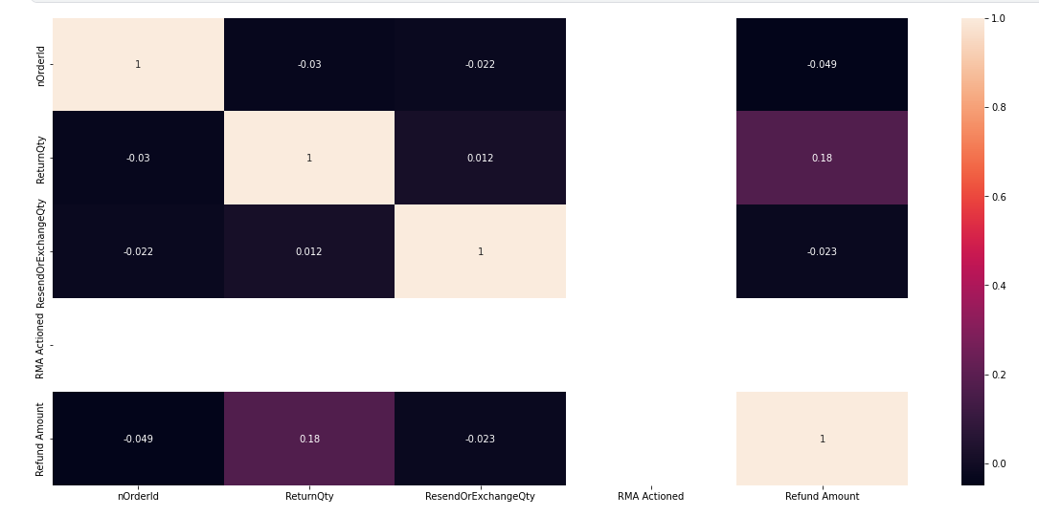

**Table 5 - Correlation Map of Returns Table**

### **Recommendations For Returns Table**

Suggestion for return table: Approximately 20% of the Refund values in the 'Type' column in the Refunds Table do not have date information. Therefore, it would be useful to add this information.

## **OTHER CAMPAIGNS**

In the examinations made in the other campaigns table, it was seen that many of the examined columns contained exactly the same values. These are: Website with Adds to cart, Adds to cart, Checkouts initiated with Website checkouts initiated, Website purchases with Purchases, Purchases Conversion Value with Website purchases conversion value, are dropped.

The completely empty Meta Add to Cart, Meta Purchases, Meta Purchase Conversion Value columns were removed from the dataset.

|  |  |
| --- | --- |
| **FEATURE (COLUMN)** | **THE FUNCTION OF COLUMN** |
| Reporting starts | * That column is mentioning about the date on which reporting starts. |
| Reporting ends | * That column contains the date on which the reporting ends. |
| Campaign name | * The campaign name which made |
| Campaign delivery | * Mentions the situation of campaign |
| Ad set budget | * This tells us the amount of the money that the seller spent on budget type basis. |
| Ad set budget type | * In this column it is mentioned that on which basis the seller spent the ad budget. (Daily or Lifetime) |
| Attribution setting | * The purpose of this column is telling the type of the ads. (28-day click or 1-day view,7-day click or 1-day view) |
| Results | * Number of Results which was aimed in Result indicator. |
| Result indicator | * The purpose of add set |
| Reach | * The number the ad reached |
| Impressions | * Total impression the ad taken (click, view etc.) |
| Cost per results | * Shows the cost per result |
| Amount spent (GBP) | * Result * Cost Per Result |
| Ends | * Shows the end date of campaign |
| Frequency | * the average number of times users see the ad. |
| Unique link clicks | * the number of people who clicked |
| Landing page views | * people landing on ad's destination URL |
| Link clicks | * the number of clicks on links within the ad that led to destinations |
| Cost per landing page view (GBP) | * the total amount spent divided by the amount of landing page views. |
| Adds to cart | * allows customers to choose items to purchase without actually completing the payment. |
| Website adds to cart | * allows customers to choose items to purchase without actually completing the payment. |
| Meta add to cart | * allows customers to choose items to purchase without actually completing the payment on Facebook or Instagram |
| Checkouts initiated | * The number of purchase launch events tracked by the pixel or Conversions API on the website and attributed to the ads. |
| Website checkouts initiated | * The number of purchase launch events tracked by the pixel or Conversions API on the website and attributed to the ads. |
| Meta checkouts initiated | * The number of initiate checkout events attributed to the ads |
| Purchases | * The number of purchases made within Meta technologies (such as Pages or Messenger) and attributed to the ads |
| Website purchases | * The number of total purchases made within the website. |
| Meta purchases | * The number of total purchases made within Meta Technologies. |
| Purchases Conversion Value | * tracks the total value of purchases made from your advertising efforts |
| Website purchases conversion value | * tracks the total value of purchases made from your advertising efforts |
| Meta purchase conversion value | * The total value of website purchases conversions. |
| Purchase ROAS (return on ad spend) | * the total revenue generated from your Facebook ads (your return) divided by your total ad spend. |
| Website purchase ROAS (return on advertising spend) | * the total revenue generated from your Facebook ads (your return) divided by your total ad spend |

**Table 6 _- Raw Features of Other Campaigns**

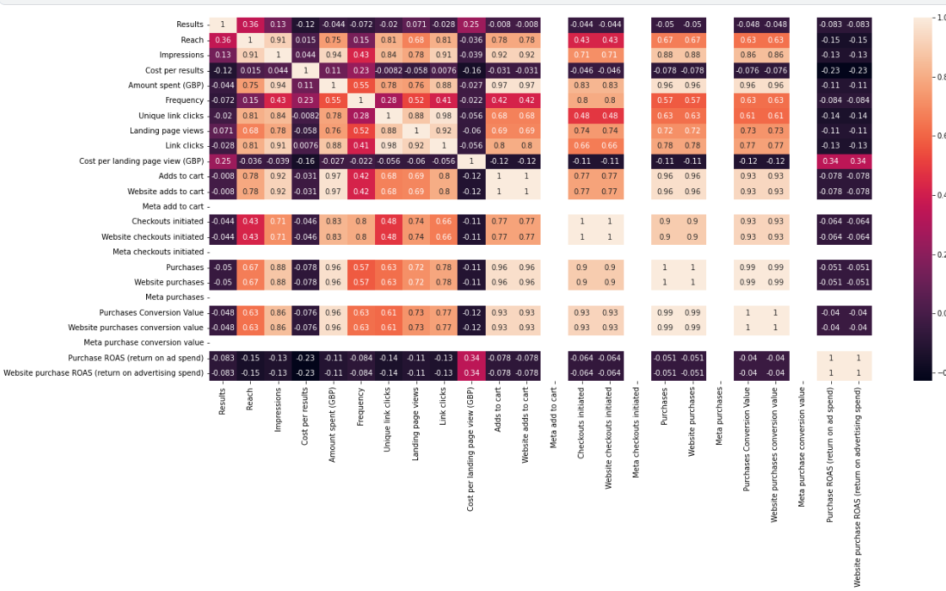

**Table 7 - Correlation Map of Other Campaigns**

|  |  |
| --- | --- |
| **FEATURE (COLUMN)** | **ACTIONS TAKEN** |
| Adds to cart | * It contains same values with Web Site Adds to cart. It is duplicated so it is dropped. |
| Meta add to cart | * It is completely null. So it is dropped. |
| Checkouts initiated | * It contains same values with Website checkouts initiated. It is duplicated so it is dropped. |
| Meta checkouts initiated | * It is completely null. So it is dropped. |
| Purchases | * It contains same values with Website purchases. It is duplicated so it is dropped. |
| Meta purchases | * It is completely null. So it is dropped. |
| Purchases Conversion Value | * It contains same values with Website purchases conversion value. It is duplicated so it is dropped. |
| Meta purchase conversion value | * It is completely null. So it is dropped. |
| Purchase ROAS (return on ad spend) | * It contains same values with Website purchase ROAS (return on advertising spend). It is duplicated so it is dropped. |

**Table 8 - Actions Taken on Other Campaigns**

### **Recommendations For Other Campaigns**

After examining the Other Campaigns table, it is thought that if columns such as Meta Add to Cart, Meta Check out Initiated, Meta Purchases are completely blank, this data behooves to be filled completely.

## **AMAZON CAMPAIGNS**

When the table was examined, it was seen that the data rows were empty in the same way and these rows were dropped. The other columns have been including significant values. Besides that, to get an idea about columns as Type, Campaign Binding Strategy, Portfolio, ROAS discussion goes further. At the and we have taken the necessary answers. Consequently, we have decided, it is recommended that the dataset stay the same with existing columns.

|  |  |
| --- | --- |
| **FEATURE (COLUMN)** | **THE FUNCTION OF COLUMN** |
| State | * That column shows the status of the campaign |
| Campaigns | * This is the name of the campaign |
| Status | * The actual status of the campaign it includes valuable information. |
| Type | * Sponsored Products (SP), Sponsored Brands (SB),  Sponsored Brand Video (SBV), Sponsored Display (SD), |
| Targeting | * choosing the specific keywords and products you wish to target and set bids accordingly. |
| Campaign bidding strategy | * When an Amazon customer performs a search for a product, the sellers with the highest bids on relevant keywords win the auction, and their product ads get listed in their chosen placement |
| Start date | * Start date of campaign |
| End date | * End date of campaign |
| Portfolio | * If you have an existing Portfolio in your account, you can optionally associate the campaign being created to a particular portfolio |
| Budget(GBP) | * A daily budget |
| Top-of-search IS | * the percentage of top-of-search impressions your campaign received out of the total top-of-search impressions it was eligible to serve on |
| Cost type | * CPC is the cost per click that an ad receives. |
| Impressions | * measure the number of times Amazon shows shoppers your Ad, regardless of whether they clicked on it or not. |
| Clicks | * Total number of clicks on ad |
| CTR | * the ratio between how many people have clicked on your Ad and the number of people who have seen it: |
| Spend(GBP) | * Total Spend for campaign |
| CPC(GBP) | * Cost per Click |
| Orders | * The number of orders taken |
| Sales(GBP) | * The amount of sales made through campaign |
| ACOS | * It compares the amount spent on PPC campaigns to the amount earned, and it helps determine if your brand generated campaigns that were cost-efficient. |
| ROAS | * ROAS (Return on advertising spend) is a metric that allows sellers to calculate the amount of income (or loss) from each invested dollar and evaluate the productivity of a particular ad campaign or even a keyword. |
| NTB orders | * The number of first-time orders for products on Amazon within the brand over a one-year lookback window |
| % of orders NTB | * The percent of first-time orders for products on Amazon within the brand over a one-year lookback window |
| NTB sales(GBP) | * The total amount of NTB sales |
| % of sales NTB | * The percentage of NTB sales |
| Viewable impressions | * This means that almost the number of measurable impressions. |
| VCPM(GBP) | * Viewable CPM represents the cost to serve only viewable impressions, which can be compared directly with the CPM that you have paid to serve all of your ad impressions. |

**Table 9 - Raw Data of Amazon Campaigns**

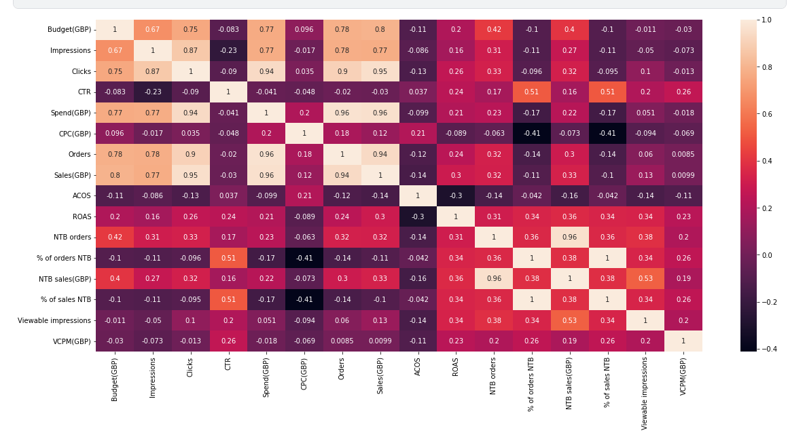

**Table 10 - Correlation Map of Amazon Campaigns**

* + 1. **Recommendatins For Amazon Campaigns**

Since most of the customer information is confidential (e.g. address information), we cannot make some inferences.

## **PRODUCT REVIEWS**

Empty data rows and unreachable video links were observed in the product reviews table. These were removed from the data set.

|  |  |
| --- | --- |
| **FEATURE (COLUMN)** | **THE FUNCTION OF COLUMN** |
| order_id | * The order id of the comment made |
| review_title | * The review title(empty) |
| comments | * The comments made by customers |
| rating | * The rating made by customers 1 to 5. (1:lowest-5:greatest) |
| status | * The status of review active or inactive. |
| date_created | * The date review created |
| sku | * The unique number of item |
| Customer ID | * The ID of customer who made the review |
| address | * Adress of customer (empty) |
| product_sku | * The unique number of item |
| product_name | * The name of product |
| product_link | * The link of review made |
| video_review_prompt_id | * Full of 199 |
| tags | * Tags of reviews |
| reply | * Replies to review made |
| reply_private | * Private reply made |
| reply_date | * The date of reply |
| published_images | * The images published by making review |
| unpublished_images | * Unpublished images by making review |
| published_videos | * Published videos by making review |
| unpublished_videos | * Unpublished videos by making review |
| source | * The source in that the comment made |
| location | * Location of customer who made the review |
| timeago | * The time indicator for how long time ago the comment or review made |
| video_first_campaign | * It is almost impossible to get insight from this column |

**Table 11 - Raw data of product reviews**

|  |  |
| --- | --- |
| **FEATURE (COLUMN)** | **ACTIONS TAKEN** |
| SKU | * We dropped the column because it has same values with Product SKU. |
| address | * It is totally an empty column we can drop it |
| tags | * There are few values but we can drop it. |
| reply | * We can drop it. There are lots of null values. |
| reply_private | * It is empty. |
| published_images | * There are few values but it won't give us insight. The links on this column are not available. |
| unpublished_images | * There are few values but it won't give us insight. The links on this column are not available. |
| published_videos | * There are few values but it won't give us insight. The links on this column are not available. |
| unpublished_videos | * There are few values but it won't give us insight. The links on this column are not available. |
| timeago | * There are few values, but it won't give us insight. Because it has a lot of null rows. |
| video_first_campaign | * There are few values, but it won't give us insight. Because it has a lot of null rows. |
|  |  |

***Table 12 - Actions Taken on Product***

### **Recommendations For Product Reviews Table**

Columns mentioned or dropped above must be taken into account to be filled if the sales system allows it to fill.